Industrial Internship Report on
”Password Manager”
Prepared by
Mayank
4VZ22CS016

Executive Summary
This report provides details of the Industrial Internship provided by upskill Campus and The IoT Academy in collaboration with Industrial Partner UniConverge Technologies Pvt Ltd (UCT).
This internship was focused on a project/problem statement provided by UCT. We had to finish the project including the report in 6 weeks’ time.
My project was Password Manager
This internship gave me a very good opportunity to get exposure to Industrial problems and design/implement solution for that. It was an overall great experience to have this internship.

TABLE OF CONTENTS
1 Preface 3
2 Introduction 4
2.1 About UniConverge Technologies Pvt Ltd 4
2.2 About upskill Campus 8
2.3 Objective 9
2.4 Reference 9
2.5 Glossary 10
3 Problem Statement 11
4 Existing and Proposed solution 12
5 Proposed Design/ Model 13
5.1 High Level Diagram (if applicable) 13
5.2 Low Level Diagram (if applicable) 13
5.3 Interfaces (if applicable) 13
6 Performance Test 14
6.1 Test Plan/ Test Cases 14
6.2 Test Procedure 14
6.3 Performance Outcome 14
7 My learnings 15
8 Future work scope 16

Preface
The past six weeks have been an enriching experience, providing me with practical exposure and hands-on learning in Python development and real-time project implementation. Undertaking this internship was crucial for my career development, as it allowed me to bridge the gap between theoretical knowledge acquired during my B.Tech and practical industry-oriented skills.
The project I undertook was the Password Manager, a Python-based application designed to securely store, manage, and generate passwords for various accounts. The objective was to create a tool that addresses the growing need for cybersecurity and password management in the digital era. This project helped me understand encryption algorithms, file/database handling, user interface design, and secure coding practices.
The internship was provided by USC/UCT, which offered a structured program, resources, and mentorship. The program was meticulously planned, starting from understanding project requirements, designing the architecture, coding, testing, and finally deploying the project. The guidance from mentors and peers was instrumental in ensuring that the project met both functional and technical standards.
During this internship, I learned not only technical skills like Python programming and database management, but also essential soft skills like time management, problem-solving, and professional communication. This experience has significantly enhanced my confidence in handling real-world projects and has strengthened my career readiness. I also gained valuable insights into project planning, requirement analysis, and effective debugging techniques. Collaborating with mentors and peers helped me understand the importance of teamwork and knowledge sharing. Additionally, working on a real-time project allowed me to apply theoretical concepts practically, bridging the gap between academics and industry standards.

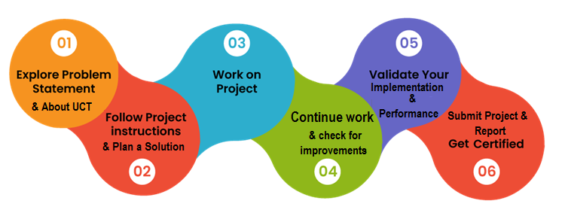
I extend my heartfelt thanks to all those who have supported me directly or indirectly during this internship, including my mentors, team members, and faculty members from USC/UCT, who guided me through every stage of the project.
Finally, I would like to share a message with my juniors and peers: Embrace every learning opportunity, stay curious, and always strive to convert your knowledge into practical solutions. Real-world projects and internships are the key to bridging the gap between theory and industry expectations.

Introduction

About UniConverge Technologies Pvt Ltd
A company established in 2013 and working in Digital Transformation domain and providing Industrial solutions with prime focus on sustainability and RoI.
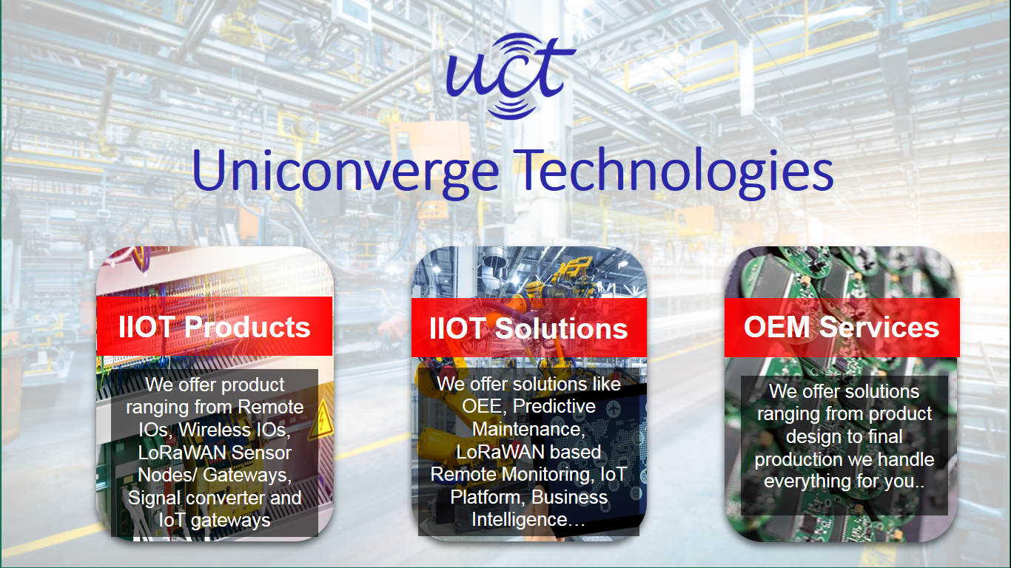
For developing its products and solutions it is leveraging various Cutting Edge Technologies e.g. Internet of Things (IoT), Cyber Security, Cloud computing (AWS, Azure), Machine Learning, Communication Technologies (4G/5G/LoRaWAN), Java Full Stack, Python, Front end etc.


- UCT IoT Platform
UCT Insight is an IOT platform designed for quick deployment of IOT applications on the same time providing valuable “insight” for your process/business. It has been built in Java for backend and ReactJS for Front end. It has support for MySQL and various NoSql Databases.
It enables device connectivity via industry standard IoT protocols - MQTT, CoAP, HTTP, Modbus TCP, OPC UA
It supports both cloud and on-premises deployments.
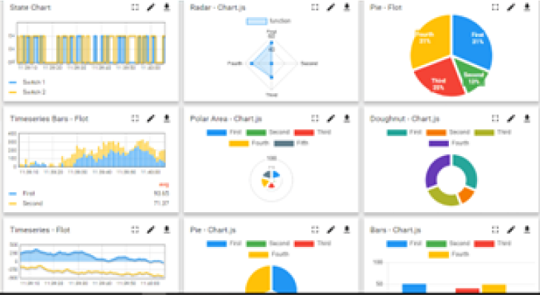
It has features to
• Build Your own dashboard
• Analytics and Reporting
• Alert and Notification
• Integration with third party application(Power BI, SAP, ERP)
• Rule Engine

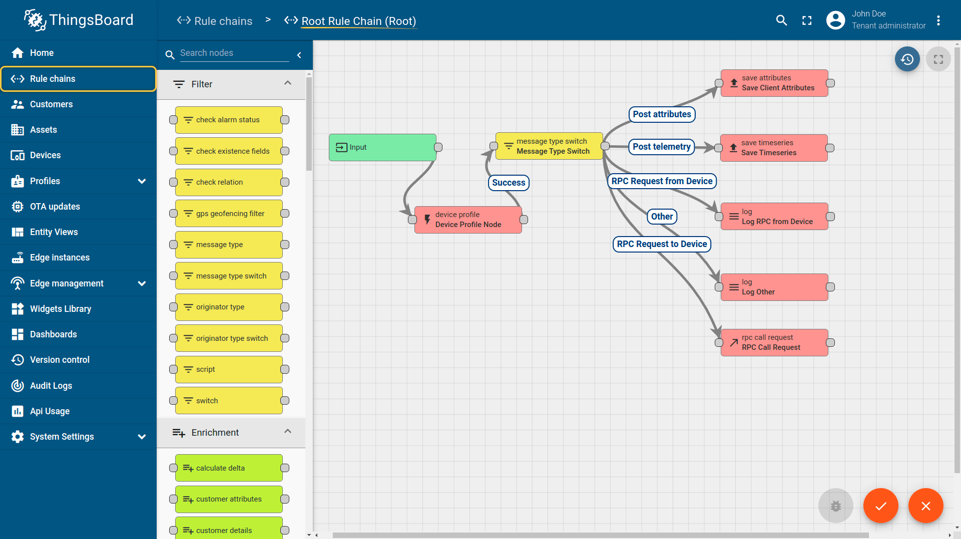
- Smart Factory Platform
Factory watch is a platform for smart factory needs.
It provides Users/ Factory
with a scalable solution for their Production and asset monitoring
OEE and predictive maintenance solution scaling up to digital twin for your assets.
to unleased the true potential of the data that their machines are generating and helps to identify the KPIs and also improve them.
A modular architecture that allows users to choose the service that they what to start and then can scale to more complex solutions as per their demands.

Its unique SaaS model helps users to save time, cost and money.

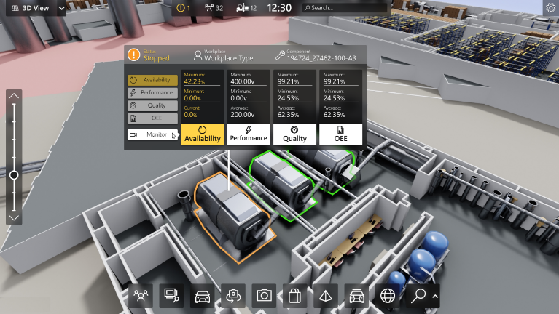
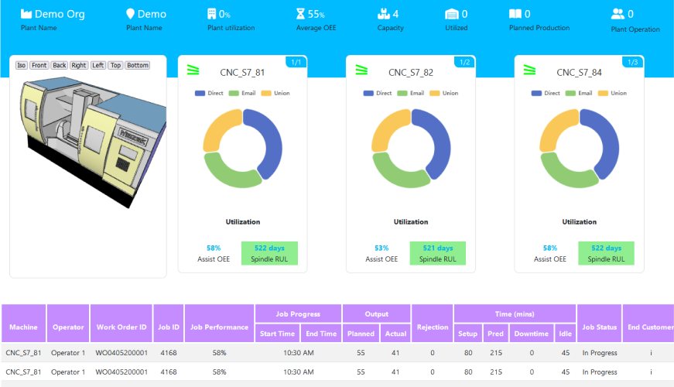

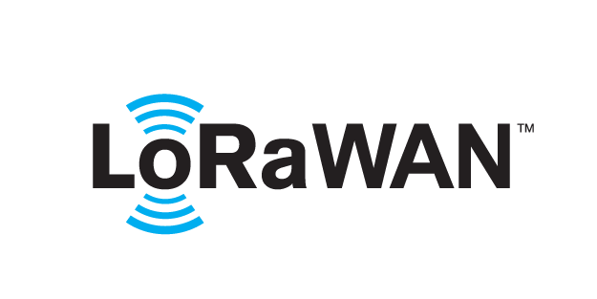
- LoRaWAN based Solution
UCT is one of the early adopters of LoRAWAN teschnology and providing solution in Agritech, Smart cities, Industrial Monitoring, Smart Street Light, Smart Water/ Gas/ Electricity metering solutions etc.
- Predictive Maintenance
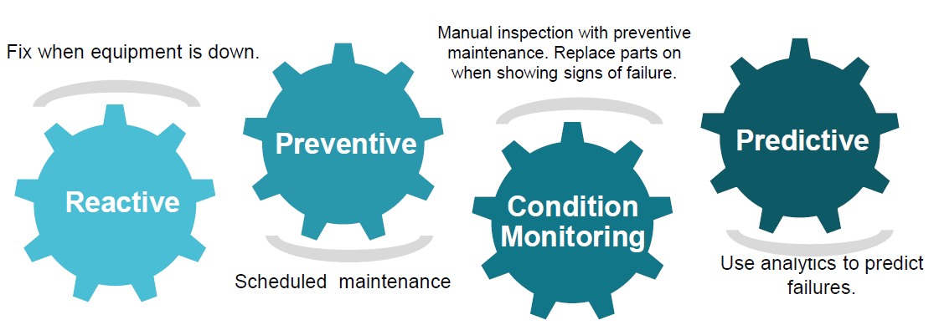
UCT is providing Industrial Machine health monitoring and Predictive maintenance solution leveraging Embedded system, Industrial IoT and Machine Learning Technologies by finding Remaining useful life time of various Machines used in production process.

About upskill Campus (USC)
upskill Campus along with The IoT Academy and in association with Uniconverge technologies has facilitated the smooth execution of the complete internship process.
USC is a career development platform that delivers personalized executive coaching in a more affordable, scalable and measurable way.






Seeing need of upskilling in self paced manner along-with additional support services e.g. Internship, projects, interaction with Industry experts, Career growth Services
upSkill Campus aiming to upskill 1 million learners in next 5 year

https://www.upskillcampus.com/
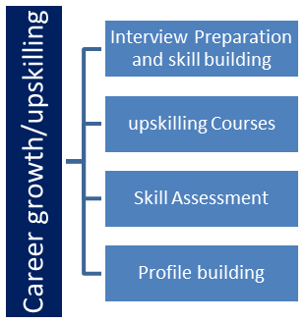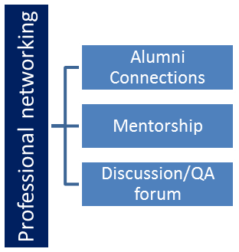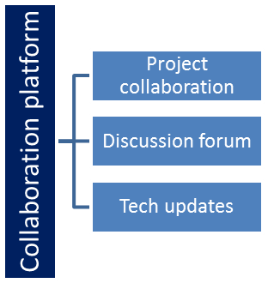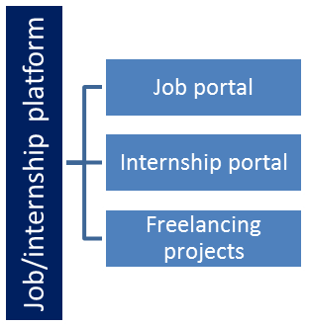

The IoT Academy
The IoT academy is EdTech Division of UCT that is running long executive certification programs in collaboration with EICT Academy, IITK, IITR and IITG in multiple domains.

Objectives of this Internship program
The objective for this internship program was to
☛ get practical experience of working in the industry.
☛ to solve real world problems.
☛ to have improved job prospects.
☛ to have Improved understanding of our field and its applications.
☛ to have Personal growth like better communication and problem solving.

Reference
[1] UniConverge Technologies Pvt Ltd Official Website – https://www.uniconverge.com
[2] IoT Academy – UCT EdTech Division, Internship Guidelines, 2025
[3] “Python Programming for Real-World Applications”

Glossary
Terms | Acronym
Internet of Things | IOT – Network of physical devices connected to the internet, collecting and exchanging data.
LoRaWAN | Long Range Wide Area Network – Low-power wireless communication protocol for IoT.
MySQL | Relational Database Management System.
UniConverge Technologies | UCT – The company providing digital transformation and industrial solutions.
Upskill Campus | USC – Career development and internship facilitation platform.

Problem Statement
In the assigned internship project, I was tasked with developing a secure and efficient Password Manager using Python. The main problem addressed by this project is the increasing difficulty for users to safely store, manage, and retrieve passwords for multiple online accounts and applications. With the growing reliance on digital platforms, many users either reuse passwords or store them insecurely, which poses a significant risk to personal and organizational security.
The problem required designing a system that could:
- Securely store passwords for multiple accounts using strong encryption.
- Allow easy retrieval and management of stored passwords.
- Generate strong, random passwords to improve user security.
- Provide a user-friendly interface for adding, viewing, searching, updating, and deleting accounts.
The goal of this project was to develop a practical, real-world solution that addresses the challenges of password management, strengthens cybersecurity practices, and helps users maintain better control over their digital credentials.
By solving this problem, the Password Manager ensures that users no longer need to rely on insecure methods like storing passwords in plain text files or reusing weak passwords across platforms, thereby reducing the risk of unauthorized access and data breaches.

Existing and Proposed solution

Provide summary of existing solutions provided by others, what are their limitations?
What is your proposed solution?
What value addition are you planning?

Code submission (Github link)

Report submission (Github link) : first make placeholder, copy the link.

Proposed Design/ Model

Given more details about design flow of your solution. This is applicable for all domains. DS/ML Students can cover it after they have their algorithm implementation. There is always a start, intermediate stages and then final outcome.

High Level Diagram (if applicable)

Figure 1: HIGH LEVEL DIAGRAM OF THE SYSTEM

Low Level Diagram (if applicable)

Interfaces (if applicable)
Update with Block Diagrams, Data flow, protocols, FLOW Charts, State Machines, Memory Buffer Management.

Performance Test

This is very important part and defines why this work is meant of Real industries, instead of being just academic project.
Here we need to first find the constraints.
How those constraints were taken care in your design?
What were test results around those constraints?
Constraints can be e.g. memory, MIPS (speed, operations per second), accuracy, durability, power consumption etc.
In case you could not test them, but still you should mention how identified constraints can impact your design, and what are recommendations to handle them.

Test Plan/ Test Cases

Test Procedure

Performance Outcome

My learnings

You should provide summary of your overall learning and how it would help you in your career growth.

Future work scope

You can put some ideas that you could not work due to time limitation but can be taken in future.

